**Vehicle claim fraud detection data review and modelling**

Dataset.head()

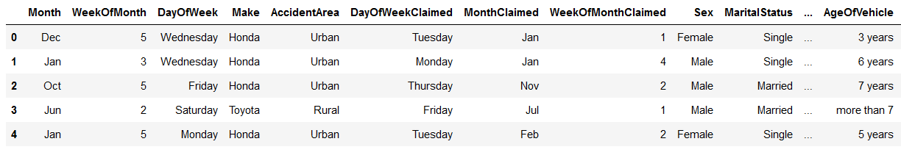

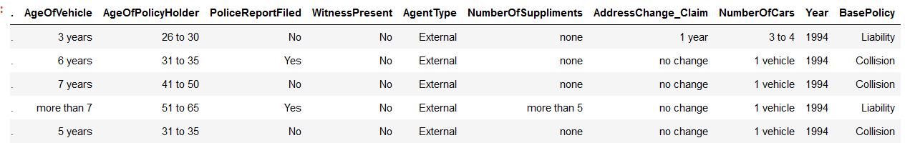

**Model Suggested**

Gradient booster classifier was used to see if it would give a better accuracy.

**Model results**

Accuracy about 97%

0.972972972972973